CARING FOR YOURSELF YOGA RETREAT
A therapeutic retreat to nourish & restore
for people living with cancer and or their carers.

Cottage Farm, Little Blakenham Ipswich IP84LZ

The schedule has been designed to support people on their journey with cancer. We invite you to join this safe space where a small group of 6-8 participants can share breathing practices to calm body and mind, meditation to find peace and stillness, nourishing and restorative yoga practices to bring back mobility and strength and discussion to welcome in acceptance and openness. The Yoga will be complemented by optional gentle walks in the garden and woods and the most nutritious plant-based food, created by chef Daphne Lambert who works with healing nutrition greencuisinetrust.org. With her deep understanding of nutrition and cancer, we are delighted Daphne can be part of this retreat.

We invite you to listen to what your body and mind needs and to take part with as much or as little as feels right. Everything is optional and times can be adjusted to accommodate different resting requirements and individual needs.

No previous yoga experience is required.

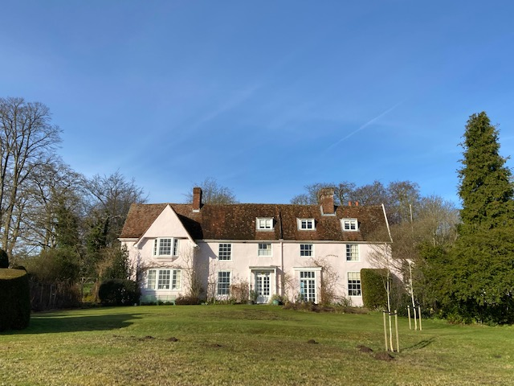

GUIDE SCHEDULE (this will be adapted to the individuals taking part)

DAY 1:
12.30pm arrive
1-2pm delicious plant based lunch with introduction by chef Daphne
2-3pm siesta, massage or gentle walk in the gardens
3-4pm gentle yoga practice with Claire ‘letting go’
4-5pm optional guided discussion ‘how to embrace openness’ with Claire with tea and cake
5-6pm siesta, massage,
6-7pm restorative yoga with Claire
7-8pm delicious, nutritious plant based supper with introduction by chef Daphne
8.30pm yoga nidra – the practice of conscious sleep with Claire

DAY 2:
9.00-9.30am silent walk and guided meditation or still meditation with Claire
9.30-10.30 nutritious breakfast with introduction by chef Daphne
10.30-11.30 rest, massage, free time,
11.30-12.30 yoga to revive with Claire
12.30-1.30 rest, free time
1.30-2.30 lunch with introduction by chef Daphne
2.30-4.00 siesta, massage, walk
4.00-5.00 optional guided discussion ‘how to embrace acceptance’ with Claire
5.30-6.30 restorative yoga, yoga nidra
7.00-8.00 delicious, nutritious supper with introduction by chef Daphne
8.30-9.00 yoga nidra – the practice of conscious sleep with Claire

DAY 3:
9:00-9.30 silent walk and guided meditation with Claire
9.30-10.30 nutritious breakfast with introduction by chef Daphne
10.30-11.30 rest, massage, free time,
11.30-1.00 gentle yoga & yoga nidra with Claire
1.00-2.00 lunch
Closing circle & depart

Yoga Teacher, Claire Whalley

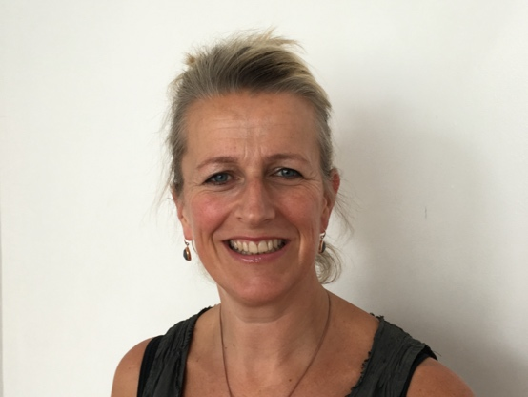
Claire Whalley is a therapeutic yoga teacher and Founder and Director of The Yoga for Life Project which, working with specialist yoga teachers, aims to bring the mental & physical health benefits of yoga to a more diverse community and into the NHS. Claire believes in the power of the breath, meditation and asana yoga practice to bring calm to body and mind and to allow the body’s natural system of self-repair to switch on.

Claire has also specialized in yoga for cancer, having completed her training with Jude Mills Healing Space – Yoga for People living with cancer. She has worked with people with cancer on zoom and in person who are recovering or receiving active treatment for many types of cancer and also receiving a range of treatments. She has also hosted retreats for people with cancer, offering them a safe space where they can feel comfortable, supported and held. By working more closely with people living with cancer, she wants to come to a deeper understanding of what it’s like to live with the condition and to respond in the best way possible using the tools of yoga, mindfulness and meditation to support each individual on their journey.

Daphne Lambert, Chef and Nutritionist

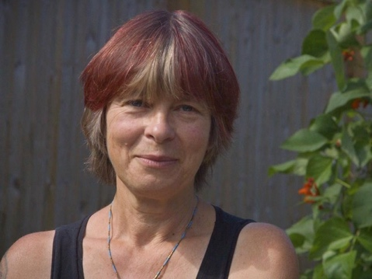
Daphne Lambert is a nutritionist, chef and author, who has cooked, studied, taught & written about food all her adult life. For 30 years she was the chef and co-owner of the first organic certified restaurant and eco hotel on the Welsh - Hereford borders.

Daphne studied nutrition at The British School of Medicinal Nutrition and has run her own nutritional therapy practice for 25 years as well as food and health retreats both for individuals and organisations.

She is the founding member of the charity, Greencuisine Trust, (http://www.greencuisinetrust.org) where she works to lower the impact our food choices have on the environment and teaches ways of growing and eating that truly nourish people.

Daphne is the author of a number of books including Living Food - a feast for soil & soul; published by Unbound 2015 & Fermenting; published by Flametree 2016.

She has contributed chapters on nutrition to Mental Wellness by Neal's Yard Remedies; published by Dorling Kindersley 2021 and The Cancer Revolution, by Yes to Life; published by Win -Win Health in 2016.

Daphne has eaten a plant-based diet for 30 years and has extensive knowledge on how to choose the right foods to live well. Her lifelong commitment to healthy food, healthy people, healthy planet has made her an authority on creating an incredible ethical, nutritionally balanced, plant rich diet.

Host: Marcia Blakenham
I am especially happy to welcome people who are having a hard time with cancer to take time out here for a few days. I have worked with Maggies Centres since their inception over twentyfive years ago and know just how hard it is to keep your equilibrium when you know that you are living with cancer. I live in this lovely place on my own, my children and even my grandchildren are grown up and I would love to share it, even briefly, with people who I know will appreciate its very special qualities.

MORE INFORMATION:

Cottage Farm:
Cottage Farm is a large easy going family house, set in farmland, with sheep grazing in the fields around. It has lovely gardens, a vegetable garden which produces plenty of fresh produce and a Woodland Garden which is idyllic in Spring, with masses of snowdrops taken over by bluebells and magnolias which flower before the other trees come into leaf. There is a swimming pool, a tennis court and a croquet lawn. It is a very tranquil, relaxed place, full of light.

The Food:

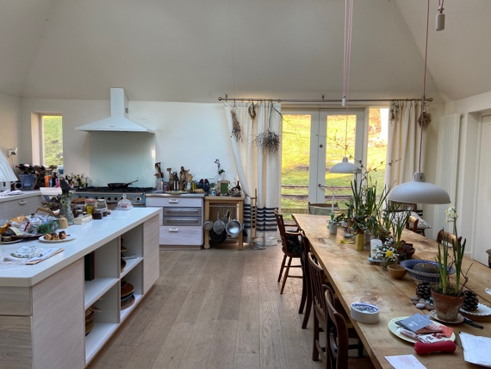

All food will be home cooked by chef Daphne Lambert and sourced locally where possible. She will be giving us sustenance with the most gorgeous plant-based cuisine which will leave you feeling nourished and lighter in body mind and soul. Food will be plant-based. For any other dietary requirements pls let us know.

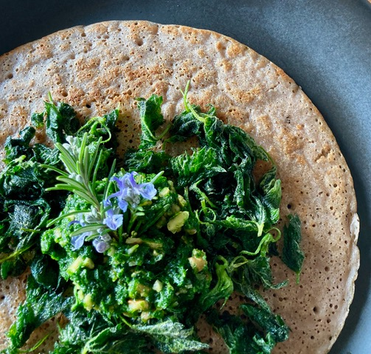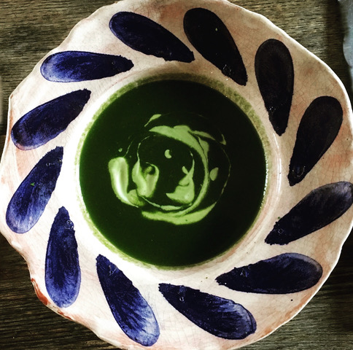

To book your place:
payment needs to be made in full, and confirmation of single or shared room and with whom by return email:
to the following bank account ref ‘first name Cottage retreat’:
£450pp shared room
£500 single room
The payment covers all board, lodging and teaching. Massages are on top £50 for 1 hour paid direct to massage therapist. Please indicate if you would like a massage.

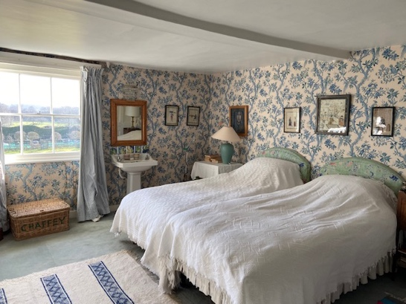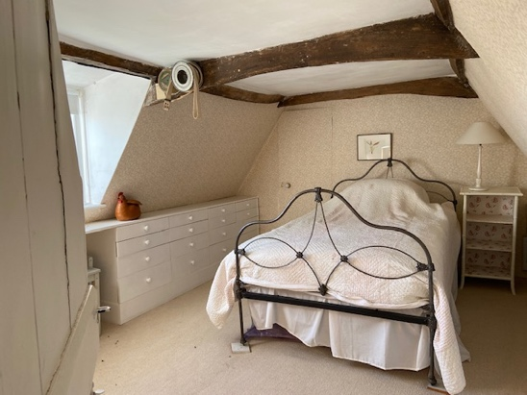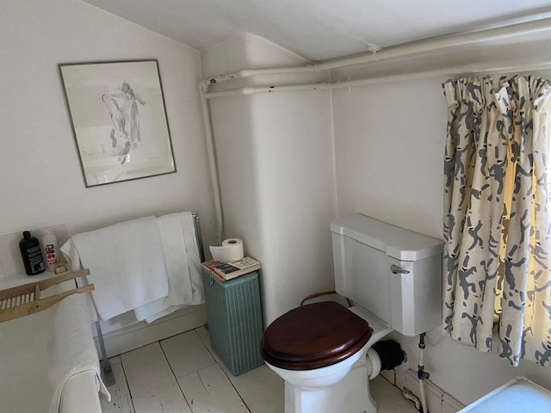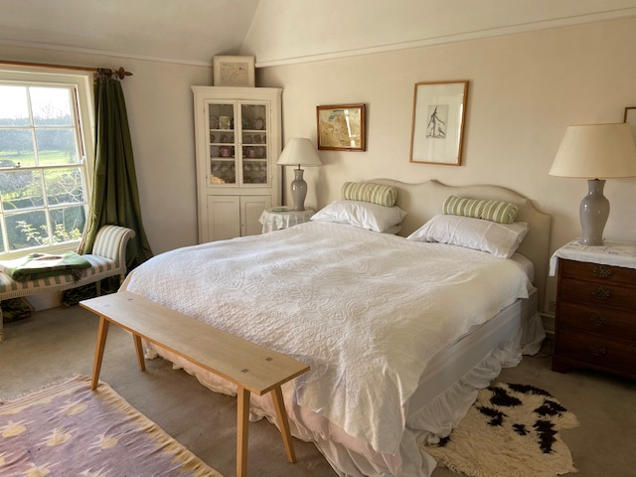

Account details:
The Yoga For Life Project C.I.C
Account number 24212881
Sort code 60 05 37

Yoga equipment:
We ask you bring your own mat. Pls also bring something – a scarf, tie, dressing gown cord which can act as a strap. If you have room to bring a cushion and a blanket if you’re travelling by car that would be great. If you have a bolster – even better but not necessary.
Pls bring your own water bottle
Pls bring a journal for making notes

Travel:
If you’re driving pop the post code in your sat nav, it should bring you to Little Blakenham and then through the Beeches housing estate and up the drive. SAT Nav will then try v hard to send you off right in front of the pink house. Resist and keep going. The pink house on the left is the one.
If you are coming by train, Ipswich is the nearest station. Let us know if you plan to travel by train and we will book a taxi to meet you at the station at 12.30 to drive you to Cottage Farm. The cost will be approx. £17

Address:
Cottage Farm, Little Blakenham Ipswich IP84LZ

Covid precautions:
We ask participants do a covid test on the morning they leave for the retreat and bring 2 more flow tests to do across the weekend. In respect to the small group, can we all take care the week in advance of the retreat to not frequent over-populated or higher risk areas if at all possible. Obviously if you feel you are coming down with symptoms do not come! We hope this doesn't happen. And so, take very good care.

Terms and conditions:
* Students receive a full discount if they cancel up to a month in advance.
* Students receive 50% if they cancel up to 2 weeks in advance
* Any cancellation under 2 weeks cannot be refunded.
* If students can fill their place then a full refund can be given on receipt of payment for the replacement booking.
* If there is a lock down students will be entitled to transfer to another date or receive a refund.
* If the teacher becomes sick or unable to take the retreat, a suitable replacement teacher will be found and the refund policy will still apply.

